Spring 2020 math Research Simulation Overview

Contents

Screen Overview 2

Variables 3

Order of Events 4

Immigrate New Birds 5

Reproduce 5

Fires 6

Winter Survival 6

Adjusting Habitat Qualities 6

# Screen Overview

Status on current events

Pink circles represent adult birds

Blue circles represent birds born this season (young/child birds)

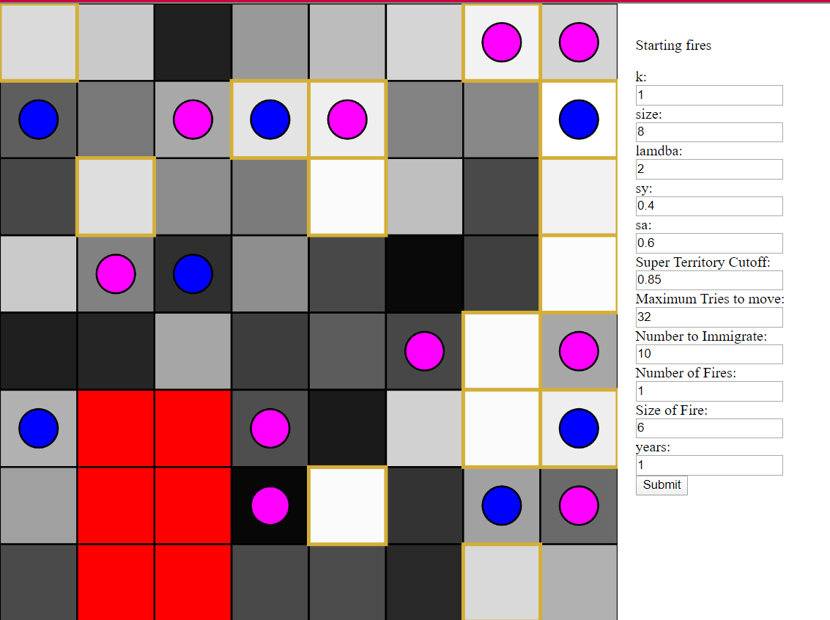

Simulation inputs

Backgrounds of square represent habitat quality (h) Black represents 0 and white represents 1

Red cells are territories with fire

Squares with gold outlines are considered ‘super territories’

# Variables

* World Variables
  + **K** – level of ‘pickiness’ of bird species, used on a $y=x^{k}$ graph to determine if a bird will stay in a territory and how successful they will be at reproduction [default: 1]
  + **Size** – number of rows and columns to have on the on-screen grid (must be a power of 2) [default: 8]
  + **Lambda**- average number of offspring in an ideal territory [default: 2]
  + **Sy**- survival rate of the youth born this season over the winter [default: 0.4]
  + **Sa**- survival rate of the adult birds over the winter [default: 0.6]
  + **Super Territory Cutoff**- The minimum quality a territory must have to be considered a ‘super territory’ [default: 0.85]
  + **Maximum Tries to Move**- the maximum number of cells a bird will try to move into before it settles [default: $⌊\frac{size^{2}}{2}⌋$]
  + **Number to Immigrate**- number of birds that migrate in each year [default: 10]
  + **Number of Fires**- number of fires that will occur each year [default: 1]
  + **Size of Fire**- number of cells the fire will affect each time [default: $⌊\frac{size^{2}}{10}⌋$]
  + **Years**- number of cycles/years to run the simulation through before outputting data [default: 1]
* Territories
  + **bird** – the bird that is living in that territory
  + **fire** – a true or false value to indicate if that cell currently has a fire
  + **h** – a habitat quality measurement (chosen from a uniform distribution of random numbers between 0 and 1)
* Bird
  + **Territory** – the territory where it is living
  + **Adult** – a true or false value to indicate whether or not the bird is an adult

# Order of Events

* Initialize Territories with correct number of rows and columns and a uniformly random number between 0 and 1 for habitat quality (h)
* For each year, the following occurs:
  + Immigrate new birds into the territory
  + Record numbers
  + Turn young birds into adult birds
  + Reproduce
  + Disperse children
  + Start fire(s)
  + Calculate survival after winter
  + Adjust habitat qualities
* Output the numerical data as csv

# Immigrate New Birds

Repeat this process for every new bird being added to the grid:

1. Set current number of tries to 0

2. Until a spot has been found or you are out of tries, do the following

a. Pick a random spot on the grid and move there

b. if someone is there, return to step 2 **without** incrementing your number of tries

c. if there is a fire at this location, return to step 2 **without** incrementing your number of tries

d. If no one is there and there is no fire, check your probability of staying by calculating: $p=h^{k}$ where p is your probability of staying at that location, h is that territory’s habitat quality, and k is the level of ‘pickiness’ of my species of bird

i. If a uniform random number between 0 and 1 is less than your probability of staying, you stay in that location. Your spot has been found, instead of going back to step 2, go to step 3.

ii. Otherwise, you increment your current number of tries and start back over at step 2.

3. Once you have found a spot or you are out of tries, your current location is your territory.

# Reproduce

1. For every existing bird calculate the number of children they will have: $c=⌊λ*h^{k}⌋$ where c is the number of children they will have, lambda is the ideal number of children they will have, h is their habitat quality, and k is the level of ‘pickiness’ of the species.

2. Calculate how many total children need to be added by adding up all of each bird’s children

3. Add that many new birds to the grid

4. Have each new bird follow the steps on ‘immigrate new birds’ so they can find a territory to live in

# Fires

1. For each fire that needs to occur that year, follow the following steps:

a. pick a random location to start the fire in

b. for however many cells need to be affected by each fire, do the following:

i. if your current location has a bird in it, tell it to move following the steps in ‘immigrate new birds’

ii. start your current location on fire

iii. pick one of the adjacent 8 cells that isn’t already on fire to move to next

iii. move to that cell and return to step b.

# Winter Survival

1. Count the current number of adults and the current number of youth in the grid

2. Calculate how many youth die: $dy=⌊y\left(1-sy\right)⌋$ where dy are the number that do not survive the winter, y is the current number of youth, and sy is the percentage of youth that survive the winter.

3. Calculate how many adults die: $da=⌊a\left(1-sa\right)⌋$ where da is the number that do not survive the winter, a is the current number of adults, and sa is the percentage of adults that survive the winter.

4. Randomly select dy youth and remove them from the grid

5. Randomly select da adults and remove them from the grid

# Adjusting Habitat Qualities

1. For every territory in the grid:

a. if that territory’s habitat quality (h) is greater than or equal to the super territory cut off, then the new value of h for that territory is a uniform random number between the current h and 1

b. if it is not a super territory, then the new value of h for that habitat is a random number from a gaussian distribution with a mean of the current h of that territory and a standard deviation of 0.2